1. Go to
   1. Wordai.com
2. Click **Login** from the top menu
3. Now you will be in this page : 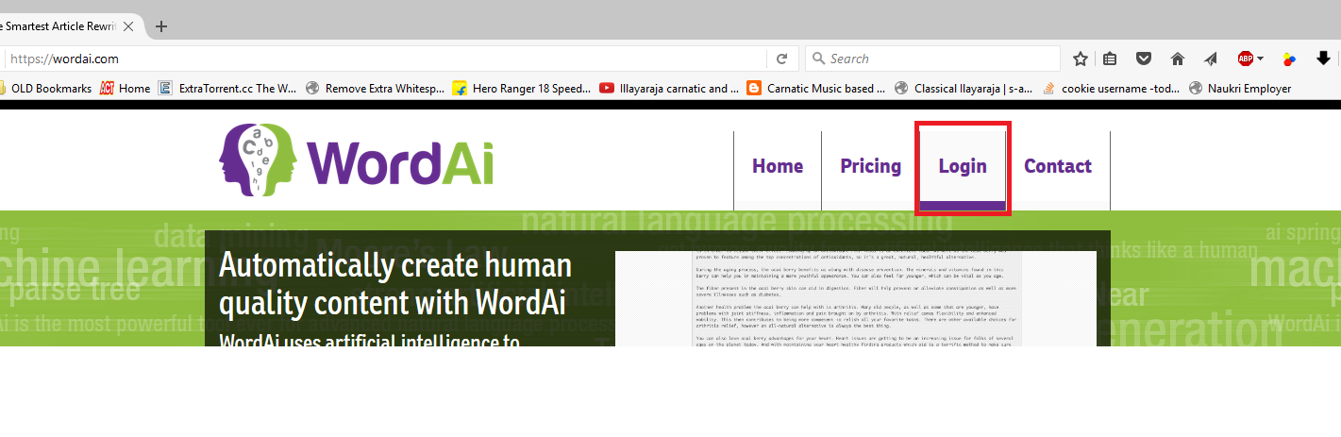
   1. <https://wordai.com/login.php>
   2. **Email** : [ramaece@yahoo.com](mailto:ramaece@yahoo.com)
   3. **Password** : ramwordai1
   4. Click **Submit**

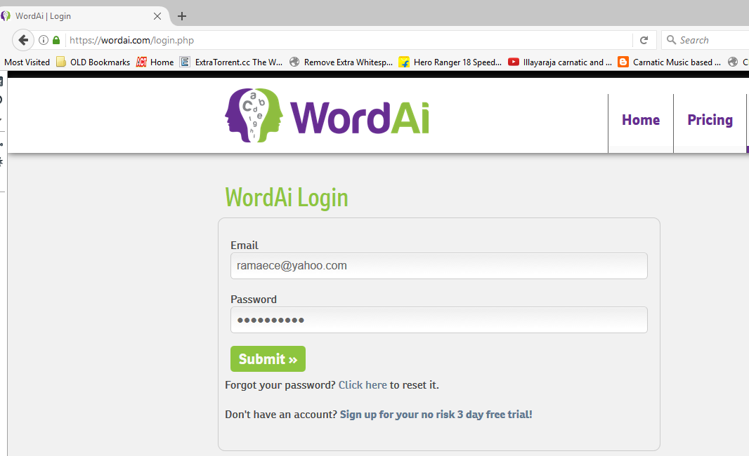

1. Now you will be in this page:
   1. <https://wordai.com/users/index.php>
   2. Hover on “**Spinner**” and then from the dropdown click “**Turing Spinner**”

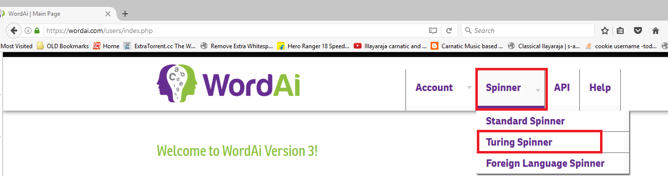

* 1. Paste the original question in the “**Article**” Box and select Spinning quality as “**Unique**” and click “**Spin Now**” button

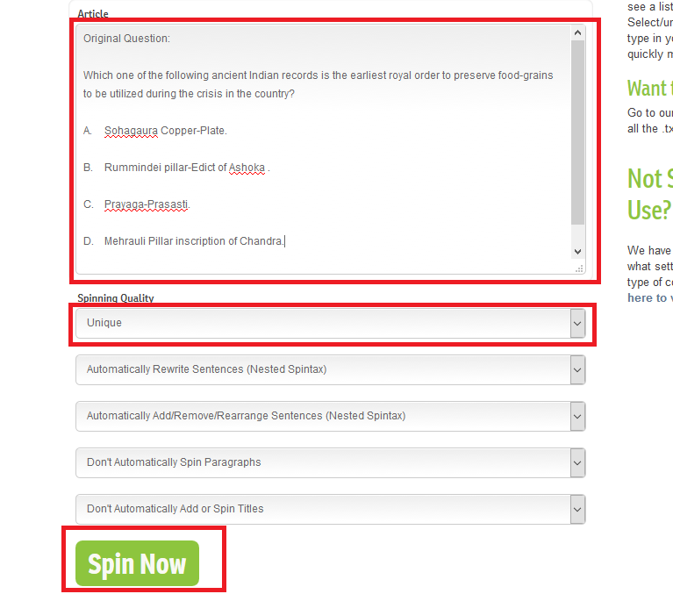

1. Now you will get the spinned version page like below after 2 – 3 minutes. Be patience till you get this kind of page
   1. I will explain you on the call how to choose your spinned question from a list